In this case, the deptno field is present in both dept and emp tables.

The data element for the field- deptno is same in both the tables. In this case Z104329DEDEPTNO.

The domain for the data element- Z104329DEDEPTNO is same in both table.

In this case domain is Z104329DOMDEPTNO.

Dept table structure is as shown below.

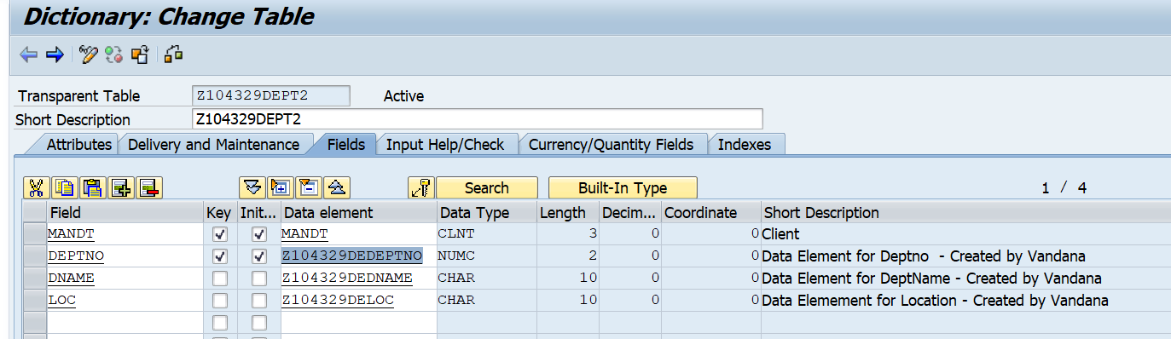

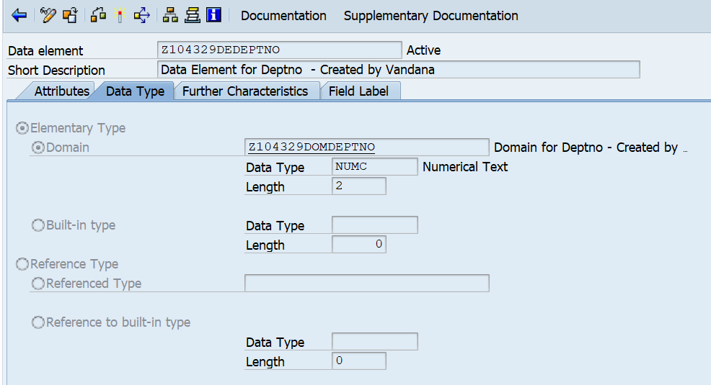

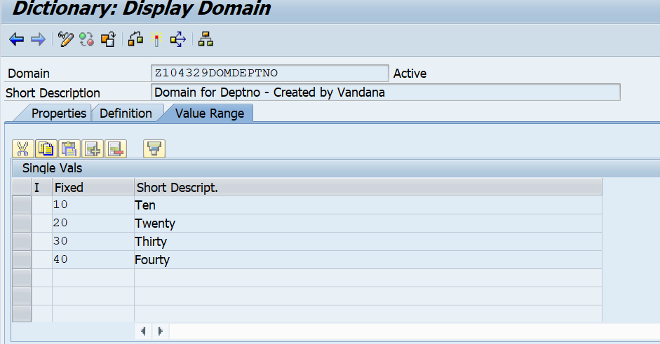

The dept table contains only 2 records.

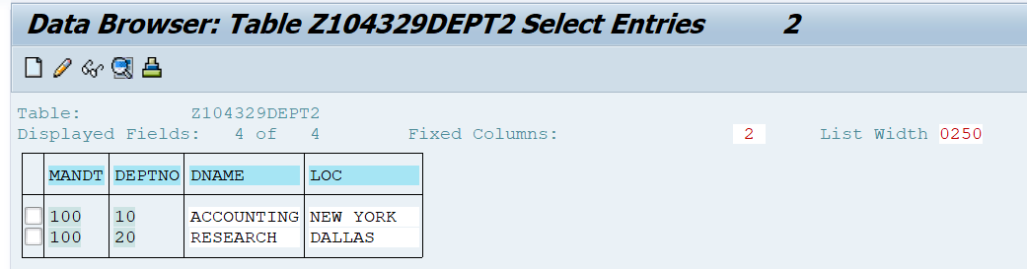

Emp table structure is as shown below.

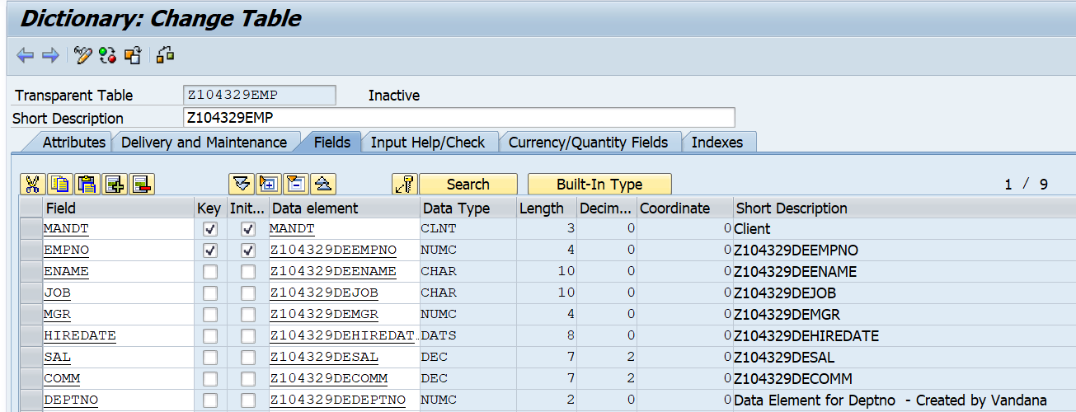

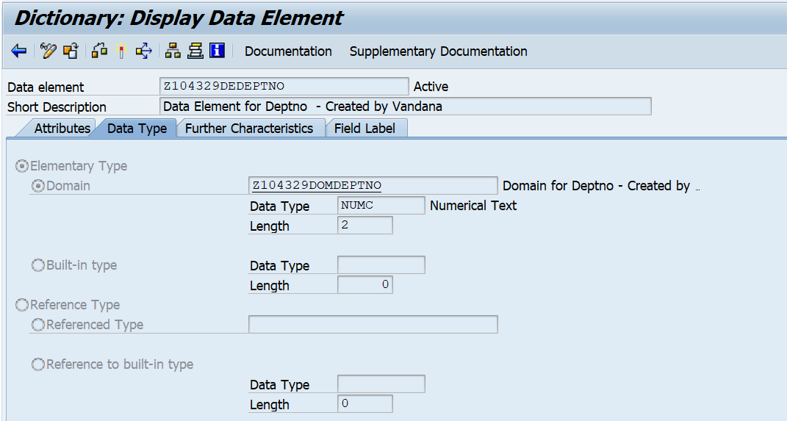

In the Emp Table, Go to Utilities-> Table contents-> Create entries.

Check values that can be entered in the deptno field of Emp Table. It shows the domain value range.

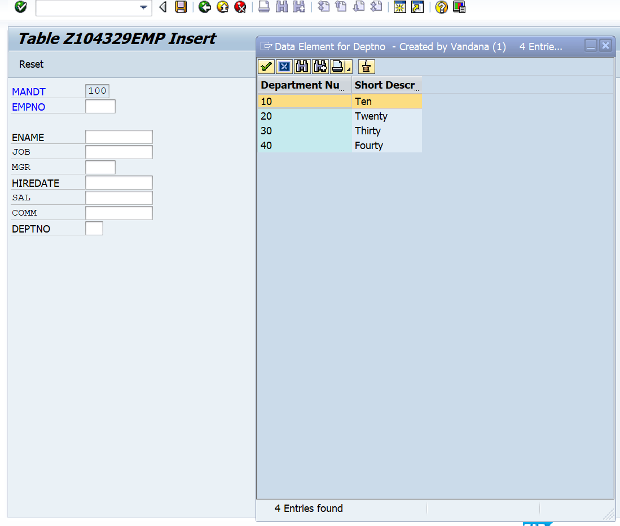

**Steps to create relationship.**

1. In SE11, go to Emp table. Select deptno field. Click on foreign keys.

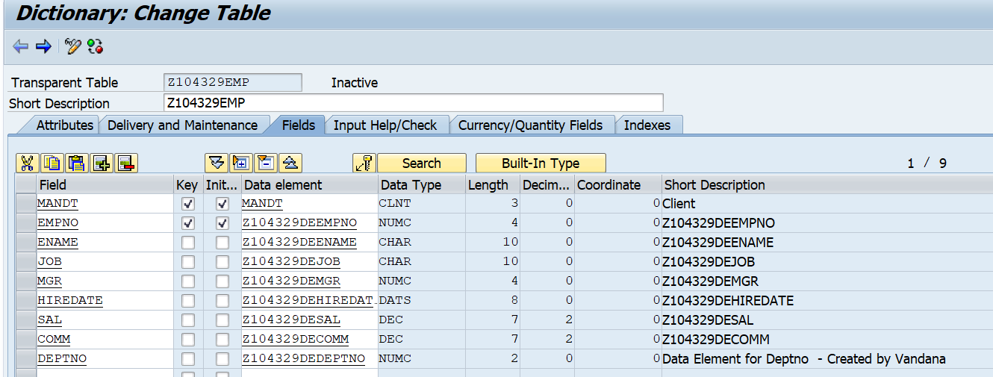

1. Enter Check table name as Dept table and click on Create proposal. After you see check table and foreign key table, click on copy.

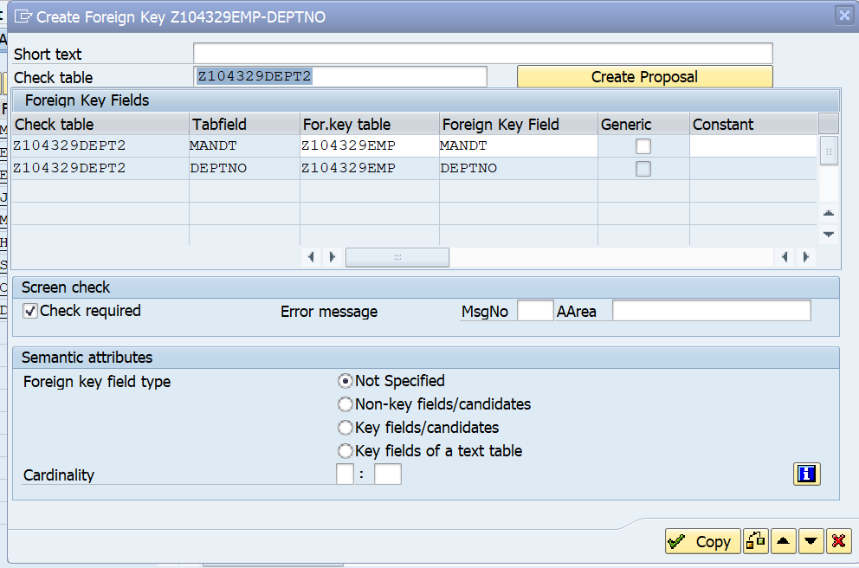

1. You will see message on status bar, as shown below. Activate the Emp table.

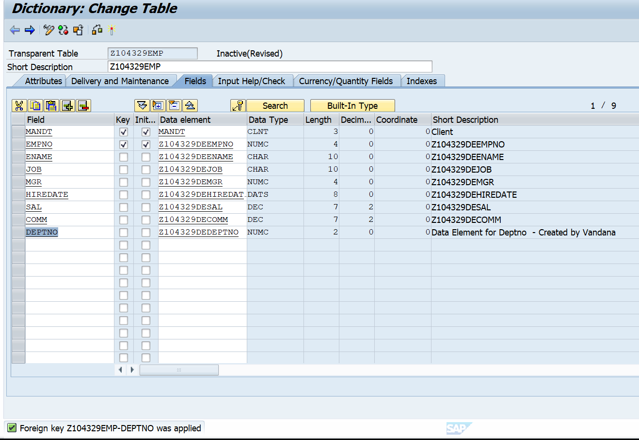

1. Go to Utilities-> Table contents-> Create entries.
2. Check values that can be entered in the deptno field of Emp Table. It shows the records present in Dept table.

